Name:_______________________________________ Date:_____________
World Religions
Mr. Mize
The Spread of Christianity
In this webquest you will be tracking the spread and growth of Christianity from its founder Jesus of Nazareth to the first split or schism in the religion.

Step 1: Beginning with the ministry of Jesus as detailed in the Christian New Testament, use the link provided to create a boundary and shade in the area that Jesus traveled during his ministry.
http://www.bible-history.com/map_jesus/
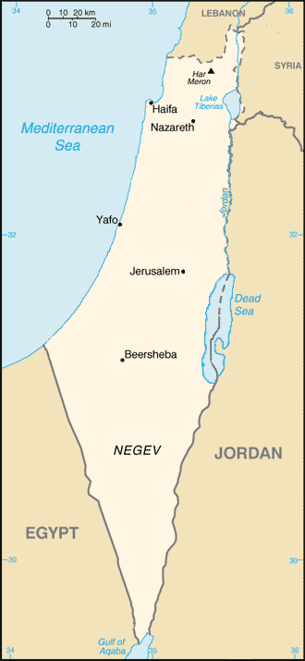
- Then mark these places on the map with the
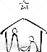
corresponding symbols.
Bethlehem – Birth Place –
Golgotha – Place of Death -

- Using the link below,
give the approximate
Time frame that Jesus began
his teachings and when
he died.
________ to __________
http://www.bible-history.com/Chart_Jesus_Chronology/

Step 2: After Jesus, the next major advancement in Christianity comes from a man named Saul of Tarsus. Begin by reading “The Conversion of St.Paul.” as well as “Paul and St. Stephan” http://ancienthistory.about.com/od/christians/p/PaulTarsus.htm
- After reading these two snippets, identify the irony about Saul/Paul’s conversion to Christianity. ____________________________________________________________________________________________________________________________________________________________________________________________________________________________________________________________________________________________________________________________________________________________
- (Hang on, it’s gonna get cheesy!!) Using the link below, plot Paul’s 3 journeys.
- Create a key to the map
- Identifies each journey individually (use color of differing lines)
- Provide the dates each journey took place in the key
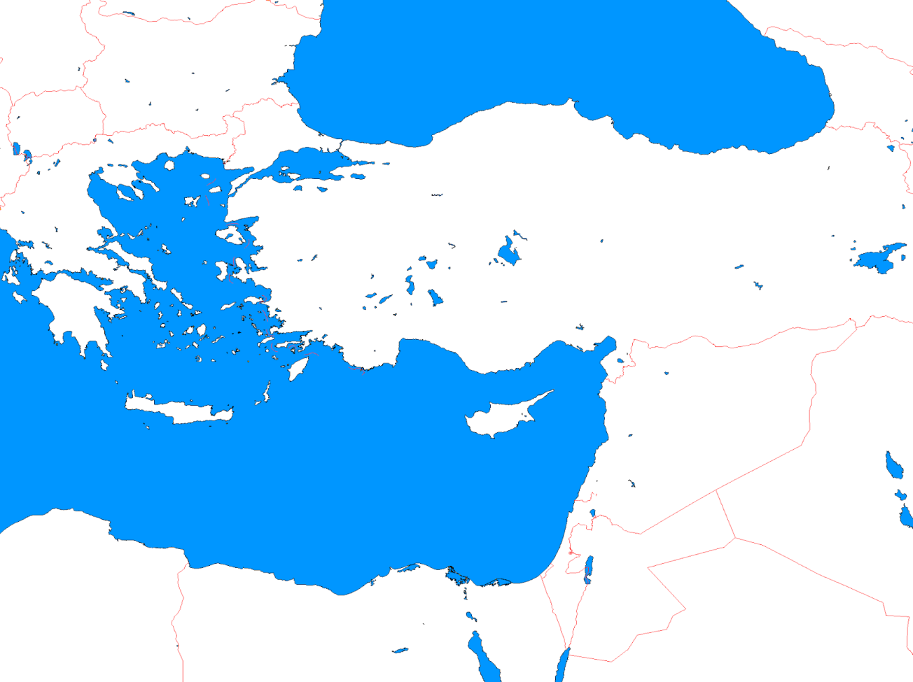
http://mrmize.weebly.com/christianity.html

KEY

Step 3: Here come the Romans! Begin reading from the link below of the Romans and Christianity.
http://www.patheos.com/Library/Roman-Catholicism/Historical-Development/Early-Developments.html
Use complete sentences for all of Step 3.
  - Summarize how Rome treated the Christians in the early 1st and 2nd centuries. ________________________
________________________________________________________________________________________________________________________________________________________________________________________________________________________________________________________________________________________________________________________________________________________________________
  - Explain Constantine’s influence of Christianity. ________________________________________________
__________________________________________________________________________________________
__________________________________________________________________________________________
____________________________________________________________________________________________________________________________________________________________________________________
  - Explain Theodosius’ influence of Christianity._________________________________________________
________________________________________________________________________________________________________________________________________________________________________________________________________________________________________________________________________________________________________________________________________________________________________
- What was the significance of the Conference of Nicaea to modern Christianity
(Open google search) _________________________ _______________________________________
- Infer: How do you think the Romans both helped and hindered Christianity?_________________________
__________________________________________________________________________________________________________________________________________________________________________________________________________________________________________________________________________________________________________________________________________________________________________________________________________________________________________________________________________________________________________________________________________________________________________________________________________________________________________________________________________________________________________________________________________________________________________________________________________________________________________

Step 4: The Great Schism. Read from the link below
http://www.patheos.com/Library/Roman-Catholicism/Historical-Development/Schisms-Sects.html
  - Using the link below, attempt to define these words from context.
Heretic / Heretical: __________________________________________________________________________
____________________________________________________________________________________________________________________________________________________________________________________
Papal / Papacy:_____________________________________________________________________________
____________________________________________________________________________________________________________________________________________________________________________________
Excommunicate: ___________________________________________________________________________
____________________________________________________________________________________________________________________________________________________________________________________
Using this link to complete the following.
http://www.theopedia.com/Great_Schism
  - What was the Great Schism?_______________________________________________________________
__________________________________________________________________________________________
- When did it happen? __________________
- What where the 2 new denomination created from the Great Schism?_______________________________
_______________________________________________________________________________________

Step 5: Mapping the Great Schism. http://travelconditions.biz/constantinople-map-1054/
Using the link above
- Plot the areas of each new denomination of Christianity.
- Identify the Capitals of each area.
- Create a key that identifies the plotted areas and the Capital cities.
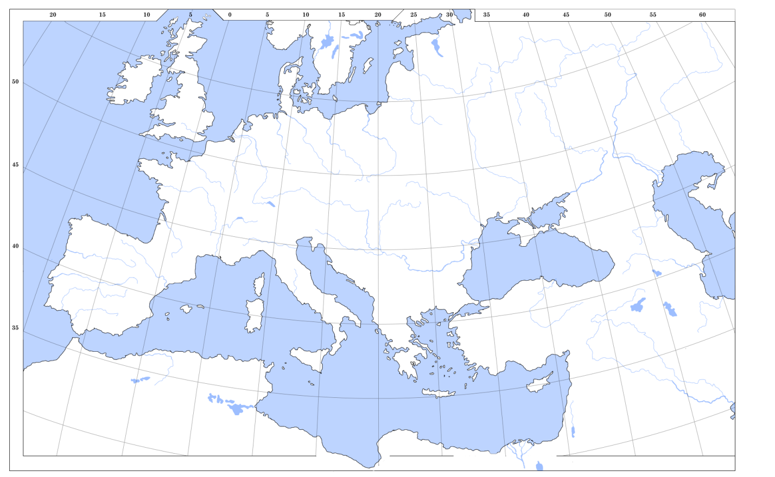

Key

